This week NAtURe NEWS

* Forest : Someday, even wet forests could burn due to climate change.

<https://www.sciencedaily.com/releases/2020/09/200930094745.htm>

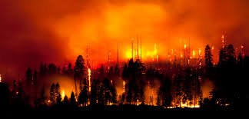

# Climate: Iodic acid influences cloud formation at the North Pole.

# <https://www.sciencedaily.com/releases/2020/10/201001090145.htm>



# Alien species to increase by 36% worldwide by 2050.

# <https://www.sciencedaily.com/releases/2020/10/201001090143.htm>

# Weird ribbon worm video - Business Insider

# Melting Antarctic Uncovered Preserved 800 to 5,000-Year-Old Penguins

# <https://www.natureworldnews.com/articles/44515/20201004/meltingantarctic-uncovered-preserved-800-5-000-year-old-penguins.htm>

# 

# October 2020: A Rare Blue Moon Month

# 

# Zombie fires in a warming Arctic region a cause of worry and a new fuel to climate change.

# <https://www.downtoearth.org.in/news/climate-change/zombie-fires-in-a-warming-arctic-region-a-worry-study-73605>

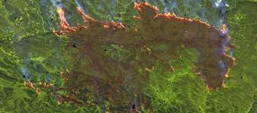

# Greenland ice melting fastest in 12,000 yrs: Study

Increased loss likely to raise sea level 2-10 cm by the end of 21st century



# France to ban use of wild animals in circuses, marine parks



## Indigenous Tribes Are Using Drones to Protect the Amazon

<https://happyeconews.com/2020/10/04/indigenous-tribes-are-using-drones-to-protect-the-amazon/>

